Step 3: Choose the Intended Audiences

Primary and Secondary Audience Segments (with Rationale for segment selection)
PRIMARY AUDIENCES

Primary audience 1: Pregnant women – Pregnant women are the primary caretakers of newborns. Informing women of how to care for their newborn properly and to help prevent serious infections is crucial to the infant’s survival. Pregnant women can be segmented by where they live, education, age and other factors, depending on what communication channels best reach them and what characteristics matter in terms of newborn care behaviors.

Primary audience 2: Grandmothers and family members who provide newborn care – Often a mother is supported by relatives in caring for newborns, and the advice and knowledge of family elders and those in good family standing is highly valued in making decisions that directly impact the health of the new baby. Therefore, it is important to reach this audience with best practices for cord-care, particularly in the context of social norms and cultural practices in the care of new babies.

Primary audience 3: Traditional birth attendants (TBAs), CHWs – TBAs and CHWs are frontline workers in their communities and often have a deep understanding of the customs in their community. TBAs in some settings can have a lot of influence over newborn care practices. It is important to note that any intervention targeting TBAs and CHWs with the goal of improving newborn health would need to cover more than cord care and address the full ENC protocol for better impact (breastfeeding initiation, wiping instead of washing the baby, skin-to skin contact, etc.). Supervisors need to have a clear understanding of any new roles or information these workers are being asked to provide to their communities. It might be necessary to conduct additional research around provider biases and other drivers of provider behavior that could be used inform the audience profile and strategic design.

Primary audience 4: Skilled birth attendants (SBAs) – Skilled birth attendants receive specific training to ensure safe delivery for mother and child. If they are from a different part of the country, for example, they might not have a deep understanding of the customs where they practice, so they need to ensure they are well-informed. They can have a strong influence on newborn care practices and should apply chlorhexidine to the cord stump immediately after cutting the cord. It is important to note that any intervention targeting SBAs with the goal of improving newborn health should address the full ENC protocol. It might be necessary to conduct additional research around provider practices, biases, and other drivers of behavior that could be used inform the audience profile and strategic design.

INFLUENCING AUDIENCES

Influencing audience 1: Antenatal care providers – ANC providers have close contact with expectant mothers during their pregnancy, and can play an important role in helping mothers prepare for healthy caregiving and prevention of infection once the baby has been delivered. Messages for ANC providers should be centered on helping mothers prevent neonatal sepsis and cord infection through proper chlorhexidine use and delivering with a skilled and equipped birth attendant.

Influencing audience 2: Fathers and community members (in the context of meanings assigned to cord care outcomes and, for fathers, cost) – While pregnancy and newborn caregiving may be seen as traditionally “women’s responsibilities,” the father of the child is often the decision-maker on expenditures related to caring for the newborn. Community members and leaders can be crucial in disseminating information and helping change community norms.

Influencing audience 3: Retail pharmacists or social marketers – Pharmacies and social marketing are a potentially important distribution channel for chlorhexidine. Objectives and messages should be tailored to the roles of pharmacies and social marketers in the area and address their needs, such as concern for profit and fast-moving inventory.

It will be necessary to conduct additional research around local population health seeking behaviors and providers of newborn care, such as identifying who is likely to provide cord care immediately after birth and in the following days, and use this research to define the primary and influencing audiences and to inform the audience profiles and strategic design. The people who most influence newborn care will vary by and within countries, and may differ between the public, faith-based, and private sectors. With cord care, it is also important to consider meanings assigned to: the condition of the cord, how long it takes to fall off, where it falls, and vulnerabilities related to the cord, for example. If delays in the cord falling off are taken to mean that the husband is cheating, for example, if will be very important to sensitize the mother, husband, and community at large to the fact that chlorhexidine typically causes a delay – to avoid blame and consequences.

Audience Profiles
PRIMARY AUDIENCE 1: PREGNANT WOMEN
Halima, 34, expectant mother living outside of Abuja, Nigeria
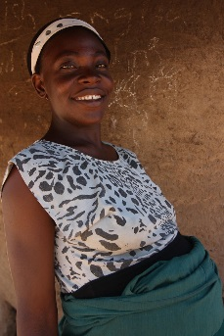
Halima is pregnant, married, with 3 boys, ages 9, 6, and 4. Her first child died soon after birth, at home. She had her next child at the district hospital and the third one at home alone because the baby came too fast. The next time, she stayed with a relative who lived closer to the health center as her due date approached. Halima keeps a small vegetable plot and owns a few chickens; she earns extra money selling vegetables and eggs. She wants her children to attend school so she saves her money carefully. Her husband has gone to the capital city to look for better work, and he comes home some weekends; he sends money when he can, to her mobile phone. Halima’s house has an old latrine, and she gets water from a nearby stream. Halima attends the community health talks when the health worker comes several times a year. She has been preparing for some time for the birth of this child. Even though she is six months pregnant, she has not yet had time to go and wait at the ANC clinic. She plans to do so this month. The nearest health center is 10 kilometers away, and she plans to deliver there. For her other children, she cleaned the umbilical cord with salty water daily until it fell off, as advised by her mother-in-law.

Mercy, 19, Ganze, Kenya.
Mercy is 19 years old, married, and pregnant with her first child. She completed primary school and then worked on her family’s farm until she married. Now she sells grains and flour in the market. Her nearest health center is 20 kilometers from where she lives. She has made two ANC visits so far and expects her baby to be born in four months. She does not know if she will be able to deliver at the health center because it is so far away. Her older sisters have all delivered at home. She is a little bit afraid because she has known or heard of several women who either died in childbirth or lost their child within months. She is looking forward to being the best mother she can be. Her mother and older sisters give her lots of advice. The custom in her family is to put breast milk on the umbilical cord every day until it falls off.

PRIMARY AUDIENCE 2: GRANDMOTHERS AND FAMILY MEMBERS WHO PROVIDE NEWBORN CARE
Mrs. Tiwari, 57, grandmother, Deoghar District, Jharkhand State, India.
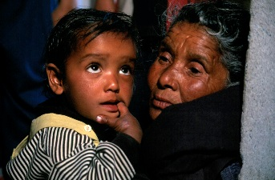
Mrs. Tiwari is very proud that her son is married, has one child plus a new one on the way, and that he has a job to provide for his family. Her daughter-in-law is respectful and is good at keeping the home, and they get along well. Mrs. Tiwari raised four healthy children by asking her own mother-in-law for advice and remedies, and she expects her daughter-in-law to now consult with her on how to deliver and care for the new baby. Her family has a long tradition of applying mustard oil to the umbilical cord stump after birth and until it falls off. She is certain that this protects the child. Mrs. Tiwari cares about her family’s reputation and does not want her daughter-in-law to stray from tradition or have to keep the newborn hidden for too long in case the neighbors begin to comment. Ms. Tiwari listens to the radio and speaks to her friends at the temple each morning, and they share stories about their families.

Ngone, 40, older Sister, Zinguinchor, Senegal.
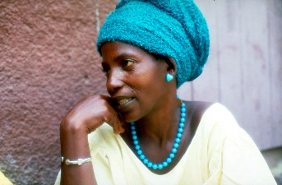
Ngone is 40 years old and has given birth to 8 children with the help of a traditional birth attendant. One of her children died within weeks of his birth. Another died before age 3. Some of her deliveries were difficult, but she and most of her children survived. She believes the old ways are good ways since they have worked for generations. When the government opened a health center in her village, she began taking her children for immunization. Nonetheless, she rarely seeks health care at the government facility, preferring to seek assistance from her long-trusted healer. She is helping her much younger sister prepare for the birth of her first child and will be there when the child is born.

PRIMARY AUDIENCE 3: TRAINED BIRTH ATTENDANTS AND COMMUNITY HEALTH WORKERS
Nora, Traditional Birth Attendant in Copán Ruinas, Honduras.
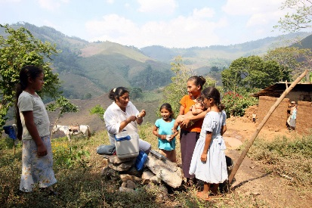
Nora has been delivering babies in her village for 10 years, following in the footsteps of her mother and grandmother and their mothers and grandmothers before them. She has received limited training from a local NGO, focusing on use of a clean delivery kit and referring women with danger signs. Delivering babies provides income and prestige for her, and she is very concerned about the welfare of women and children in her village. She is happy to refer her women for prenatal care, but she does not feel that the health center staff value what she does. She does not normally give new mothers advice on cord care, nor does she follow up with women if the delivery is normal. Sometimes she is consulted if the mother or baby has a problem in the days after birth.

Kanta, Community Health Worker outside of Dhaka, Bangladesh.
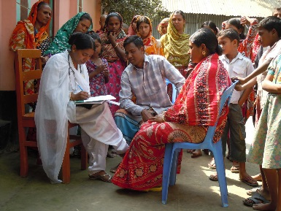
Kanta is a community health worker in Bangladesh. She is a mother with two children, ages 7 and 10, and after attending several health education sessions, she was invited to be a community health worker. Kanta was trained by an NGO to distribute mosquito nets several years ago and recently received training on ENC. She visits households and gives talks in the communities to educate pregnant women and young mothers. Kanta is proud that women consult her on their children’s health and she is now recognized and welcomed in all the villages she visits. She welcomes the idea of selling chlorhexidine for cord care to help new mothers and further increase her income. Kanta enjoys her work even though she has to travel in the hot sun or the rain, and she only earns a small amount from each product. Mothers are often reluctant to buy from her, saying that traditional treatments are less expensive, so Kanta spends a lot of time trying to convince community leaders and others about the right treatments. She would like more information to explain why chlorhexidine is better and safer.

PRIMARY AUDIENCE 4: SKILLED BIRTH ATTENDANTS
Tanvi, Nurse-Midwife, Rajasthan, India
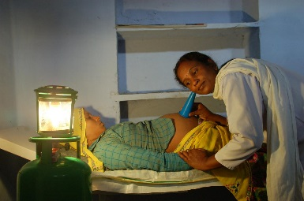
Tanvi has been delivering babies at the health center for 15 years. She likes her work and tends to have a good social status and recognition in the community. Women who deliver with her bring their own supplies, based on a list given during ANC visits. Given the limited supplies available at the health center, she has little choice but to use what the women bring. She has learned that 7.1% chlorhexidine digluconate is now part of essential cord care, but has not received any training or information in its use. She does not see the women after they deliver and go home, so she does not spend much time educating them about how to care for their new babies. She believes they learn that at the ANC clinic and from relatives who have given birth before. She cares about the women and her reputation so does everything she can to make sure the deliveries are successful.

OB/GYN Dr. Indira Khan, MBBS, FICOG, Lahore, Pakistan.
Dr. Khan is proud of what she has accomplished in life, including her education and her position as a doctor in one of the busiest health facilities in Lahore, and a small private clinic she operates evenings and weekends. She stays updated in medical education by attending conferences and government trainings, and she is a member of the local medical doctors association. She cares about her patients, especially the young mothers and mothers-to-be, and she wants to give them the best possible care. However, Dr. Khan sees more than 50 patients a day, including several deliveries. She may not spend as much time as she would like educating her patients about the medicine she prescribes or how to prevent illnesses in the future. She has noticed that quite a few of the women she delivers bring in their babies back to the hospital with cord infection -- after they have tried several home remedies. She wonders why CHWs and ANC nurses do not do a better job educating mothers about newborn care. She is unaware of the extent to which her patients apply other substances to the cord stump and of what some of those substances are.
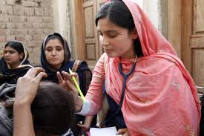
INFLUENCING AUDIENCE 1: ANTENATAL CARE PROVIDERS
Sadia, ANC nurse, 27, Chittagong, Bangladesh
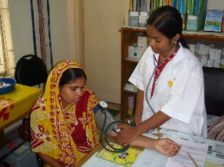
Sadia works at a local health center and provides screening to all pregnant women in the community. She is often overwhelmed by the number of women to see in a day, and she knows that people complain about long lines and waiting. As a result she may be taking shortcuts in the way she does her work or giving patients limited information about what to do or expect during pregnancy and childbirth. She is unsure how often neonatal sepsis or serious cord infection occurs in her area and unaware of 7.1% chlorhexidine digluconate as a simple, cost-effective way to prevent it. She knows that although she is meant to see mothers four times during their pregnancy, they may: 1) delay the first visit, 2) receive ANC care from multiple care settings, or 3) skip visits. As a result, she is also unsure of the next time she will see her clients and it is unlikely that she provides all four ANC screening visits to the same woman. Typically, she does not mention newborn care during visits before month 6 or 7 of gestation because she does not think the mother-to-be will remember anyway. Nor does she typically ask women where they intend to deliver or advise them to deliver with a skilled attendant. She is unsure what women in the community traditionally put on umbilical cord stumps (she is from another part of the country) and has found that, in general, women rarely cease traditional practices despite advice from health care providers.

INFLUENCING AUDIENCE 2: FATHERS AND COMMUNITY MEMBERS
Marco, married father, 30, Atauro, Timore-Leste.
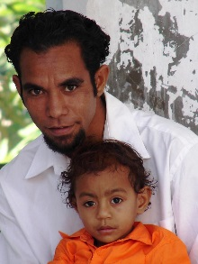
Marco has two children, ages 8 months and three years. He works in construction, and has been working consistently during the past few years. He is happy and proud that his wife is expecting their third child, but they do not normally discuss the pregnancy or what happens at her ANC visits – that is the women’s domain. He is proud that his children are healthy and that he is able to support his wife so she can be dedicated to managing the home and taking care of the children. He is responsible for making decisions for and about his family on everything from health care to education to regular purchases. Marco gives his wife money for food and supplies when she asks for it, and he wants to know how she is spending their income. Marco relies on his wife to know how to prepare for birth and take care of their children’s healthcare but he worries that she spends too much money on medicines, since his own mother used home remedies to care for him and his siblings. He has never accompanied his wife to the health center and rarely goes there for himself. Marco’s wife knows she will have to have all the supplies she needs ready whether she gives birth at home or at the health center. Marco’s mother is helping and advising her, as she always has. His friends and neighbors consult the pharmacist when they need health supplies and health care.

Lin, female community leader, 40, Thanlyin township, Myanmar.
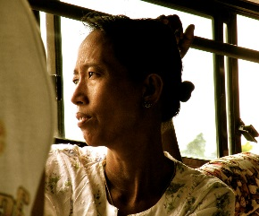
Lin leads a local women’s group and has five children. She wants to see the condition and position of women in her community improve. Her group holds monthly meetings where they discuss problems and what is going well. They also share solutions and things they have learned. Each month they focus on a specific topic in addition to open discussion on whatever attendees are concerned about at that time. Group members also contribute a small sum of money each month to give to the member whose turn it is to receive. The women use this money for special purchases – seeds, equipment, preparing for a new child, health care, or large household items, for example. Lin knows the life history of everyone in the group and regularly pays them visits, listens, and gives advice. She has seen too many babies in her village die within the weeks after birth. She believes in some traditional ways, but she also sees the value in modern ways, including modern health care.

INFLUENCING AUDIENCE 3: RETAIL PHARMACISTS OR SOCIAL MARKETERS
Sam Mussa, Pharmacy Manager, 42, rural northern Nigeria
Sam manages a small pharmacy and shop. His brother is a trained pharmacist and owns several pharmacies in the region. Sam prides himself on having learned about medicine and treatment of common illnesses working with his brother. He knows that the community respects his knowledge and that his pharmacy is often the first place families come for medical advice. He was trained on clean delivery kits and treatment of childhood illnesses by NGO programs, and he appreciates the job aids that the NGOs give him to help explain it to pregnant women preparing for birth. Pregnant women come to him to get supplies they need for delivery and for cleaning the umbilical cord. He usually recommends methylated spirits for cleaning the cord stump. When caregivers come with prescriptions from doctors or when they know what medicine they want, he will just sell them what they ask for, but if they ask his advice, he will offer several options. Pharmacy companies sometimes provide promotional materials to decorate his shop, pens and notepads. These representatives are knowledgeable, friendly and they offer him incentives to prescribe the medicines they promote, so he regularly follows their advice.

Martha, Social Marketer outside Kampala, Uganda
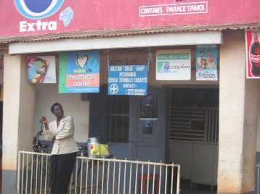
Martha manages a mid-sized kiosk in a suburb of Kampala. She has lived in the community all her life and people trust her advice and the products she sells. People often come to her kiosk because the pharmacy is too far away. She earns money selling a variety of medicines, such as ORS and zinc, which helps support her children’s education. She has not heard about chlorhexidine for umbilical cord care and does not know what to recommend for cord care when families ask.

