Step 3: Choose the Intended Audiences

Primary and Secondary Audience Segments (with Rationale for segment selection)
The proposed audiences are illustrative of existing intended audiences in several countries and typical situations where ECPs would be the best option. However, it is highly recommended for each country to conduct additional research to identify the most relevant profiles. It is also important to understand that the need for ECPs is most likely driven by behaviors rather than by socio-demographic attributes. Therefore, aspects to take into account when defining an intended audience should cover not only key socio demographics such as age, place of residence (urban, rural) and relationship status (single, married, divorced) but also situations such as the partner’s location (at home or not), the desire for children (delaying, spacing, limiting), the period of life (transition into marriage, out of marriage, becoming a widow), the risk of sexual or intimate partner violence, and whether or not it is a crisis setting.

Although health system officials and decision-makers are a potentially important influencing audience, they are not included in this communication strategy as key messages for advocacy on ECPs are found in Scaling Up Lifesaving Commodities for Women, Children, and Newborns: An Advocacy Toolkit, which provides advocacy resources for utilizing the Commission platform to raise awareness and engage stakeholders in addressing commodity-related gaps in policy. See: http://www.path.org/publications/detail.php?i=2381

PRIMARY AUDIENCES

Primary audience 1: Women of reproductive age (with sub-audiences, e.g. by life-stage - age, parity and/or location)
- Sub-audience 1a: Unmarried adolescent girls (15-19) – Many adolescent girls are hoping to finish secondary school and further their education. However, they are also becoming sexually active and are not necessarily well-informed about their contraceptive options. As a result, many of them become pregnant and drop out of school.
- Sub-audience 1b: Women not using a contraceptive method or having experienced method failure –This group includes women older than the adolescent group, married or unmarried, who are at risk of pregnancy due to not using a contraceptive method or having experienced method failure.
- Sub-audience 1c: Women at risk of sexual violence, including intimate partner violence, and those living in humanitarian crisis settings – In this group are mostly women at risk of being raped, whether in crisis settings or in areas with a high rate of sexual violence.

Primary audience 2: Pharmacists and pharmaceutical counter staff - Pharmacy staff include the pharmacist in charge of the outlet as well as staff working behind the counter. Depending on their background, their knowledge about ECPs may be very basic or inexistent. In most cases, pharmacy staff need to be better informed about the product and its mode of action. They also need to learn strategies to counsel clients adequately and without bias.

Primary audience 3: Clinical providers (public and private) - Clinical provider bias and lack of knowledge on ECPs has been identified as one of the key barriers to increased uptake of ECPs.

Primary audience 4: Community health workers (CHWs) or distributors (public and private) – The non-clinical provider is a frontline worker based at the community level, often in the same community in which she lives. As the primary point of information (and sometimes also primary point of distribution) for remote communities, community-based health workers need to have accurate knowledge about ECPs, mode of action, and where to access it so that they can adequately counsel women in need.

Primary audience 5: Responders to gender-based violence, including those in crisis settings – Police officers or refugee camp workers are the primary point of contact for women who have been victims of sexual violence and as such, they need to have knowledge of ECPs, and be able to either administer or refer to appropriate services.

INFLUENCING AUDIENCE

Influencing audience 1: Male partners and friends – Male partners can have significant influence, positive and negative, on their female partners when it comes to accessing ECPs. Similarly, friends can influence a woman’s choice of using ECPs.

Audience Profiles
PRIMARY AUDIENCE 1: WOMEN OF REPRODUCTIVE AGE
Sub-audience 1a: Unmarried adolescent girl
Malita, 17, Kabala, Sierra Leone.
Malita is a young girl, aged 17, who lives with family members in Kabala, Sierra Leone. She is attending the local secondary school and is hoping to stay enrolled. Her hopes for life are to better herself through continuing her education or learning a trade. She is beginning to have sexual relationships occasionally, though sometimes unwillingly, with boys her age and also older men. She does not want to go to a health clinic to get information on family planning methods because her friends have had negative experiences or poor treatment by clinic staff. Malita has heard about HIV, but is more worried about getting pregnant as it might mean dropping out of school. She does not feel comfortable negotiating condom use with partners and thinks just mentioning it to a man will make him break off the relationship.

Sub-audience 1b: Women not using a contraceptive method or having experienced method failure

Mary, 36, Kalangala District, Uganda.
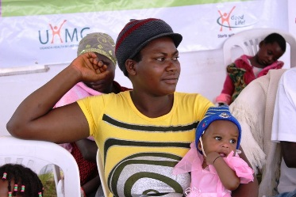
Mary is in her mid-thirties and divorced. She lives in an urban area, with her children and her young sister who helps around the house. She is a working professional, with advanced education and high economic status. She is a typical “early” adopter of new technologies and rather independent in her choices. She has a partner at times but does not live with him and tends to have sex only occasionally. She usually uses condoms as her preferred method to protect herself against STIs and pregnancy, but at times, she and her partner forget. There have also been times when the condom has broken. She does not see the need to use an additional contraceptive method since she has infrequent sex. She has heard of ECPs but believes it can end an already established pregnancy so is against using such measures.

Sub-audience 1c: Women at risk of sexual violence, including intimate partner violence and those living in humanitarian crisis settings

Lucia, 24, Mizimba District, Malawi.
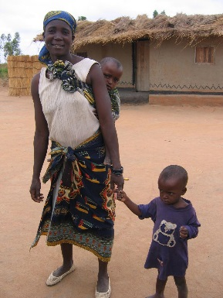
Lucia lives in a low-income household where every day is a struggle. She has four children and does not want more because she does not have enough resources to take care of them. Her husband does not have a stable employment (he has to find some work every day) and Lucia is doing small jobs (growing and selling vegetables or fruits) to gather additional income. Her husband tends to drink and comes home very late once or twice per week wanting to have sex and then fall asleep. He will get angry and violent if something does not go his way, and sometimes hits her. He never wants to talk about money, and Lucia is afraid he will get upset if she even tries to discuss using some of their sparse income to go to the health clinic for a family planning consultation. Lucia is a good candidate for a contraceptive method such as injectables, but she finds it difficult to attend the family planning clinics without her husband finding out, and is afraid he will beat her if she goes without his permission.

Sarifina, 30, mother living in Kissidougou Refugee Camp, in Guinea.
Sarifina lives in a refugee camp in Guinea. She had to flee her home due to political instability and high rates of violence. She is in the camp with her three children and is waiting for the political unrest to subside before heading back home. She is at risk of gender-based violence, including rape from people leaving nearby, sometimes relatives, soldiers, or men in the camp. She does not currently use a contraceptive method since she does not have regular access to family planning services.
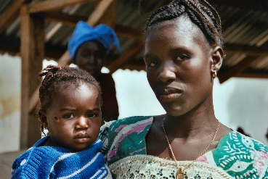
PRIMARY AUDIENCE 2: PHARMACISTS AND PHARMACEUTICAL COUNTER STAFF
Issa, manager of a local pharmacy in Bamako, Mali.
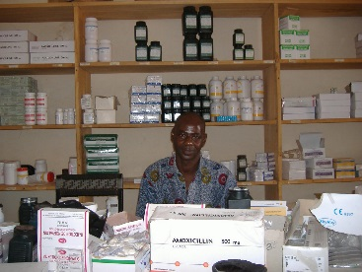
Issa is in charge at a local pharmacy in Bamako and helps clients with their requests. He has a diploma in pharmaceutical technical assistance (which is less comprehensive than a pharmaceutical degree) and has been hired by the pharmacy owner to manage the outlet. He reports to the owner and involves him in decision-making when necessary, but on a daily basis, he is the main point of contact for clients. He only has basic information about contraceptive methods and is not formally trained about ECPs. He has occasional demand for this product – which typically comes from young women in their 20s who may not feel comfortable going to clinics. Sometimes he tries to convince clients to avoid repeat use. He also lacks the time and space to counsel the client in private and has no formal training and little motivation to encourage the use of other family planning methods.

PRIMARY AUDIENCE 3: CLINICAL PROVIDERS
Sara, 32, a nurse working in a primary care facility in Kaduna, Nigeria.
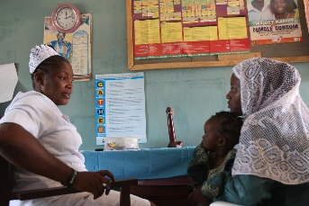
Sara is proud of her education, what she has accomplished in life and the position she holds at the health facility. Even the young doctors sometimes will ask her advice on counseling young mothers. Sara’s pride shows in her dedication to her work and to the people she serves. At times, this pride fosters a belief that she knows more than her clients and therefore knows what is best for them. Sara may not spend as much time as she could in really talking with her clients, getting to know them, and counseling them in a way that provides them with the information they need to make the choices best for them. She is familiar with common family planning methods but not so much with ECPs. She is not sure that ECPs are allowed in her country, because many people think it causes abortion. She is not very confident about the dosage and timing for use so she would hesitate to mention it to a client. She thinks ECPs are used by promiscuous people so if someone comes asking for ECPs, she may not be very friendly or open about it. She is not sure how safe ECPs are and whether there are any long-term side effects.

PRIMARY AUDIENCE 4: COMMUNITY HEALTH WORKERS OR DISTRIBUTORS
Susan, 28, a community health worker in the peri-urban neighborhoods of Kampala, Uganda.
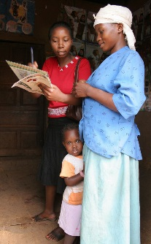
Susan has developed strong peer-to-peer relationships with women in her area, which are built on trust and mutual understanding. Because of these strong relationships, she is able to communicate openly with her peers and community. In addition, Susan is often the first person women in her area approach with questions about family planning. She is proud of being a resource in the community and being looked upon as someone with a lot of knowledge on health issues. She was trained by a local NGO to talk about family planning methods three years ago, so her job aids are well-worn. Because she does not provide clinical services, she has more time to sit with members of the community and give them information on and referral for contraceptives. She is able to distribute oral contraceptives and condoms; she is also able to distribute ECPs. However, because she is member of the community that she serves, she has some of the same attitudes, social norms and beliefs of her community that prevent her from talking with certain clients about ECPs, especially younger women or women she believes should not be having sex. She also faces resistance and embarrassment because she is so well known to community members and is embarrassed to talk about issues that may seem much too personal. These beliefs can sometimes get in the way of providing appropriate unbiased information. She is open to learning more about family planning methods and gaining more skills, given the opportunity.

PRIMARY AUDIENCE 5: RESPONDERS TO GENDER-BASED VIOLENCE, INCLUDING THOSE IN CRISIS SETTINGS
Officer Okafor, 39, a police officer in Lagos, Nigeria.
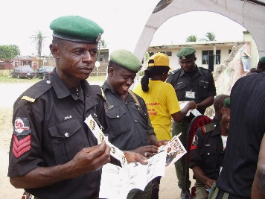
Officer Okafor is a man in his late thirties. He works at the local police office in Lagos, Nigeria. He deals with robberies and petty crimes, and was recently trained on guidelines for handling sexual assault complaints. In his neighborhood, it is not uncommon for women – especially young ones – to be assaulted at night by strangers. Women usually show up at the police office a few hours after being attacked or are brought by relatives or family members after being found. Per his training, he takes their deposition and gives the victims information on medical services they should seek for further assistance but often doubts the validity of the woman’s story and does not think about the potential risks for HIV and unintended pregnancy.

Sonia, 28, refugee camp worker, Kiziba, Rwanda.
Sonia is a young woman in her late twenties. She works as a reproductive health advisor in a refugee camp in Kiziba, Rwanda. In her camp, she sees many women and children who had to flee their homes due to local armed conflicts. Some of these women were raped prior to arriving to the camp and are also at risk of rape within the camp itself. While Sonia is not able to ensure their protection at all times, she wants to make sure that she has access to all tools and supplies for them to avoid unwanted pregnancies and HIV.
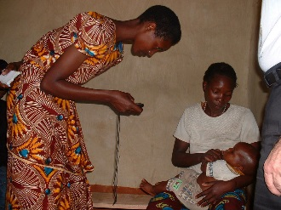
INFLUENCING AUDIENCE 1: SUPPORTIVE MALE PARTNERS AND FRIENDS
Sanjeev, 27, a male partner of a breastfeeding mother, living near Pune, India.
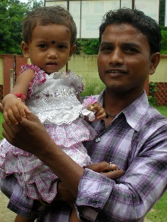
Sanjeev lives in the outskirts of Pune, India. He is in a stable relationship and is supportive of his partner using a contraceptive method of her choice. At the present time, his partner is not taking a regular method because she is breastfeeding a young baby, and he is concerned that she might become pregnant. He is willing to use condoms but in case the method fails, he wants to make sure his partner gets access to another contraceptive option such as ECPs.

Winnie, 22, a young mother, Esabalu, Kenya
Winnie lives in Esabalu, Kenya and had an unintended pregnancy and became a single mother at 16. She had to drop out of school and she is now feeling limited in her options for education and for life in general. She wants to make sure that young girls like her do not go through the same ordeal, and she is interested in being trained on key family planning messages to help girls in her community.

