Step 3: Choose the Intended Audiences

Primary and Secondary Audience Segments (with Rationale for segment selection)
PRIMARY AUDIENCES

Primary audience 1: Women of reproductive age (with sub-audiences, e.g. by life-stage - age, parity and/or marital status)
- Sub-audience 1a: Young unmarried woman, pre-childbearing– Many young women today are delaying marriage and family in order to further their education and/or career. Because many of these women are sexually active and do not want children until later in their lives, increasing their access to long-acting family planning options, such as implants, can support their reproductive and life choices and reduce unintended pregnancies.
- Sub-audience 1b: Married woman, pre-childbearing– Just as unmarried women are delaying marriage and family for education and/or career, married women are also waiting to start a family in order to save money and be financially prepared for the costs of raising a child. Increasing access to family planning methods, including implants, reduces unintended pregnancies and allows couples to plan to start their families when they are best suited to provide for a child’s overall wellbeing.
- Sub-audience 1c: Married woman who wants to space her births – Increasing access to family planning methods, such as implants, promotes healthy birth spacing and continued family planning which allows the couple to prepare for a growing family if they choose to have another child. The positive effects of birth spacing are numerous and span the entire RMNCH spectrum by not only influencing the health of the mother and baby but also impacting the health and well-being of the entire family.
- Sub-audience 1d: Woman who has completed her family – Long-acting family planning methods, such as implants, are a good option for women who want no more children but may not be ready for permanent methods.

Primary audience 2: Clinical providers (public and private) - Clinical provider bias and lack of knowledge on implants and other family planning options similar to implants, has been identified as one of the larger barriers to increase uptake of this commodity, therefore making it extremely important to address these barriers at the provider level.
Primary audience 3: Non-clinical providers such as community health workers (public and private)- The non-clinical provider is the frontline worker based at the community level, often in the same community in which he/she lives. This cadre of provider can hold a variety of titles such as Community Health Worker or Community Health Volunteer. Just as clinical provider knowledge on all family planning options including implants is crucial, the non-clinical provider is just as important as they are the link connecting the community with health services at health facilities.
INFLUENCING AUDIENCES
Influencing audience 1: Male partners of women of reproductive age- Male partners can have significant influence, positive and negative, on their female partners when it comes to accessing, choosing and implementing family planning methods.
Influencing audience 2: Extended family members and community members- Family members, friends and community members can all influence a couple’s or a woman’s choice of using contraception (including type of contraception) for family planning. Where there is lack of knowledge within a community around a certain health topic like implants, myths tend to fill that void and create fear within the community, thus negatively influencing uptake and demand.

Audience Profiles
PRIMARY AUDIENCE 1: WOMEN OF REPRODUCTIVE AGE
Sub-audience 1a: Young unmarried woman, pre-childbearing
Ada, 19, Abuja, Nigeria.
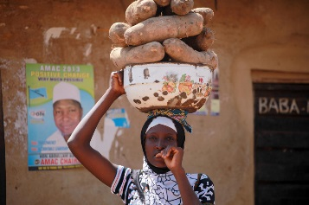
Ada is unmarried and does not have any children yet. She lives with her mother and two younger siblings. She works in the market during the mornings, helping her mother prepare breakfast for people going to work. She earns enough money to pay for her cell phone, and she is saving money to finish school. Her dream is to become a teacher. Ada has friends from her neighborhood and they socialize sitting outside their houses. They talk about contraceptive options when the CHW comes to give monthly injectable contraception in their neighborhood, but they have not heard of implants. She has recently met a man who has a good job and he visits her in the evenings. She hopes to eventually marry and have a family. She sees herself as someone who can go far with hard work and determination. She is not ready to begin a family just yet.
Sub-audience 1b: Married woman, pre-childbearing
Vibha, 21, Lucknow, Uttar Pradesh, India.
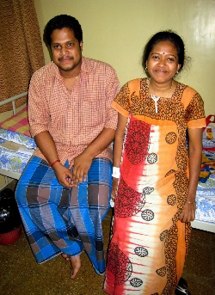
Vibha is newly married and her mother-in-law is pressuring her every day to start having sons. She lives with her husband’s parents and sister in a small house on the outskirts of Lucknow. She and her husband have talked several times about waiting to have children as they are hoping that he will soon have a new job with a better income. They feel they should save first before starting a family because education is expensive, and they want to buy a moto. She and her husband want a contraceptive option that is discreet and reversible, so that when they do want children, they will be able to have them right away. Vibha seeks health advice at a private clinic, as the wait at the public clinic is too long. Vibha is responsible for cleaning and cooking for her husband and his family, and she is beginning to make new friends with the young wives in her neighborhood.

Sub-audience 1c: Married woman who wants to space her births
Nana, 24, Mbale, Uganda.
Nana and her husband have one young son, 8 months old, and they want to wait for a while before their next child. She and her husband are both working – she is sewing clothes and he is a driver for a foreign company. Her mother and sisters help with childcare when she is working. Nana and her husband are active in their church and they have a large circle of friends and family with whom they often socialize. Nana is proud that she and her husband can afford the basic necessities for themselves and their child, but she always worries that they should be saving more as the economy is not good and she worries that an emergency will drain their family resources. They want to give their children a good education and they are saving to improve their roof. Currently they use the free condoms from the health sector, because Nana simply does not have time to go to the clinic and wait for an injection each month. Nana and her husband would like to be sure they are ready for each new child, so they want to wait before having another child.

Sub-audience 1d: Woman who has completed her family
Doma, 34, Tanga, Tanzania.
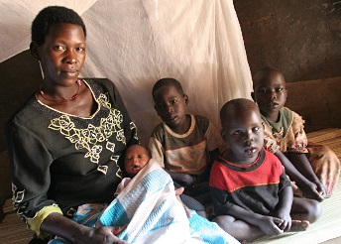
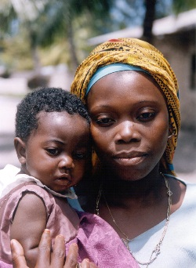
Doma has four children and she is proud that they are all healthy, strong and going to school. She does not want any more children as she has the sole responsibility of their care and well-being. Her husband works in the port in Dar es Salaam and comes home once a month. Doma is a good cook and she started a small roadside stand where she prepares lunch for workers. She is earning enough money to pay for her phone, cooking gas for her home, and school fees for her children. She and her husband want the best for their children and feel any more children would challenge their ability to provide for them. She has sexual relations only when her husband is home and he does not want to use condoms. It is hard to remember to take the pill each day and planning ahead for an injection is difficult, as she does not always know when her husband will come home. Doma wants an effective method that she does not have to think about.

PRIMARY AUDIENCE 2: CLINICAL PROVIDERS
Sara, a nurse working in a primary care facility in Kaduna, Nigeria.
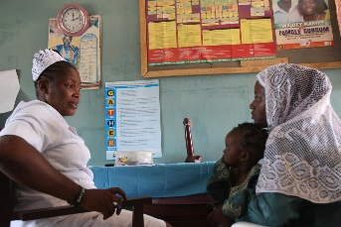
Sara is proud of her education, what she has accomplished in life and the position she holds at the health facility. Even the young doctors sometimes will ask her advice on counseling young mothers. Sara’s pride shows in her dedication to her work and to the people she serves. At times, this pride fosters a belief that she knows more than her clients and therefore knows what is best for them. Sara may not spend as much time as she could in really talking with her clients, getting to know them, and counseling them in a way that provides them with the information they need to make the choices best for them. She justifies her limited counseling time because of the number of patients she must attend to in one day. She has been providing family planning methods to married couples for many years and has her favorite methods that she often suggests over others she does not know as much about. For example, she is not confident in her abilities to insert the implant so does not mention implants much as a family planning option. She is not sure if implants are a good idea for young women who have not had a baby. Sara is open, however, to learning more about other family planning methods, even those that require clinical skills, if given in-service training.

PRIMARY AUDIENCE 3: NON-CLINICAL PROVIDERS
Susan, a community health worker in the peri-urban neighborhoods of Kampala, Uganda.
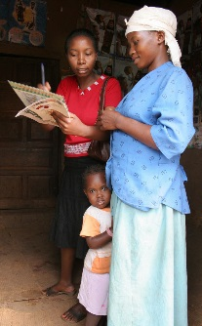
Susan is the often the first person who women in her area approach with questions about family planning. Susan develops strong peer-to- peer relationships built on trust and mutual understanding. Because of these strong relationships, she is able to communicate openly with her peers and community. Susan is proud of being a resource in the community and being looked upon as someone with a lot of knowledge on health issues. She was trained by a local NGO to talk about family planning methods three years ago, so her job aids are well-worn. Because she does not provide clinical services, she has more time to sit with members of the community and give them information on and referral for contraceptives. Susan distributes oral contraceptives and condoms, if she has the supplies. However, she is a member of the community that she serves, and she shares many of the same attitudes, social norms and beliefs of her community. Susan’s beliefs can sometimes get in the way of providing appropriate unbiased information, especially about less common family planning products. She is open to learning more about family planning methods and gaining more skills, given the opportunity.

INFLUENCING AUDIENCE 1: MALE PARTNERS
Joseph, 28, married father of two in Tanzania.
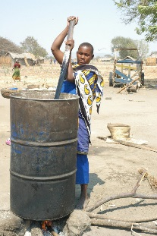
Joseph works in construction when he can and his income is often just enough to cover the basics his family needs. He feels that as the provider for the family, it is his responsibility to make decisions regarding family planning. From what he has heard from friends,, he thinks family planning – especially a long-acting method- could help him and his wife delay their next child so they can save money to pay for education for their children. Joseph would like to talk to his wife but does not know how to start the discussion and is afraid talking about it would lead to an argument or them both feeling too embarrassed. He also worries that family planning methods may not be safe, or that using family planning methods could damage his wife’s ability to get pregnant, or even cause sickness in future children. While Joseph may have difficulty expressing it, he does want the best for his wife and the children they already have or hope to have together.
INFLUENCING AUDIENCE 2: EXTENDED FAMILY MEMBERS & COMMUNITY MEMBERS
Elira, 52, mother-in-law in Elbasan, Albania.
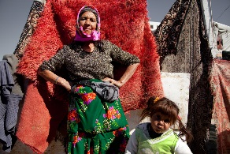
Elira is very proud that her son is married with two children, and has a job to provide for his family. Her daughter-in-law is respectful and is good at keeping the home, and they get along well. Elira knows that today’s families are often not as large as when she was a young mother, but she raised four healthy children and provided for them well, so now each day at meals, she is asking her son and daughter-in-law when they will have more children. Her son told her that they will wait for more children and his wife is considering using implants. Elira does not know about this method and she worries that it will affect her daughter-in-law’s ability to have more children. Elira listens to the radio and speaks to her friends at the market each morning, and they share stories about their families.

Mr. Asena, 45, active community member in Uganda.
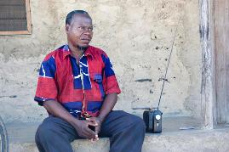
Mr. Asena owns multiple shops in a rural Ugandan town and is active in his community as well as in the church. He is quite vocal and enjoys discussing his thoughts with community members including topics around family planning even though he is not very knowledgeable in this area. His presence and influence in the community are shaping men’s perceptions on family planning and choice in a negative and restricting way.

