Step 3: Choose the Intended Audiences

Primary and Secondary Audience Segments (with Rationale for segment selection)
PRIMARY AUDIENCES

Primary audience 1: Pregnant women and their families – Pregnant women, their male partners, and other influencing family members play a crucial role in detecting warning signs of PE/E in pregnancy. Accordingly, this group needs to be well-informed about and seek out ANC. This includes learning about PE/E warning signs and symptoms, the severity of PE/E for mothers and their baby, where and when to seek care, and what care options are available.

Primary audience 2: Facility-based clinical providers (public and private) dealing with screening and treatment of PE/E – OB/GYN specialists; clinical officers; nurse midwifes; skilled birth attendants; ANC nurses, etc. – Facility-based providers are the primary users of magnesium sulfate to treat PE/E. They need accurate knowledge and skills to detect PE/E, feel confident in using magnesium sulfate, and have access to necessary supplies.

INFLUENCING AUDIENCES

Influencing audience 1: District and local health officials (Ministry / local authorities / facility management) – Health officials play a key role in ensuring that guidelines for treatment of PE/E are up-to-date and in line with the latest evidence and that providers are trained in their implementation.

Influencing audience 2: Community health workers (public and private) – CHWs play a critical role in supporting women and their families to address early identification of maternal complications such as PE/E, in particular the decision to seek care and the ability to secure transportation to the nearest health facility.

Audience Profiles
PRIMARY AUDIENCE 1: PREGNANT WOMEN AND THEIR FAMILIES
Nelly, 20, outside Nairobi, Kenya.
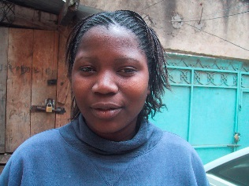
Nelly is married and is four months pregnant with her first child. She completed primary school, and then worked as house help and on the family farm until she married. Nelly now runs a small bar and breakfast nook from her new home with her husband in a rural area outside of Nairobi. Her closest health center is 15 km away. She has never visited the health center because it is too far, and would take her away from her housework and from tending the café. She plans to deliver at home, as her mother did, with the help of a local midwife. She has heard about other women in her community dying from pregnancy-related causes but is not sure about what signs she should be looking out for.

Adrivas, 32, father of two living in Nampula, Mozambique
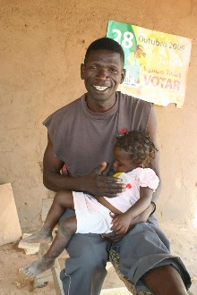
Adrivas is a carpenter and a father of two, with his wife expecting another baby. His wife was pregnant last year, but something went wrong during the labor. Adrivas is not sure what the problem was, but his wife had a difficult time with the pregnancy and the baby did not survive. For this pregnancy, his wife has been suggesting they go to the clinic before the baby is born to make sure the baby is doing alright. He wants the best for his wife and family, but he hears of women losing babies all the time, and is not sure this outcome is always preventable. Adrivas is hesitant to spend the money to travel to the clinic, and is afraid of what additional costs will be when they get there. Instead, he’s heard the local traditional healer has medicine that can be affordable or paid for with goods or services, meaning he won’t have to pull from the family’s already small income to get care for his wife. Adrivas also likes the healer can come to their home if needed, so he won’t have to worry about his wife traveling in case of an emergency.

Gloire, mother-in-law, 61, North Kivu, DRC
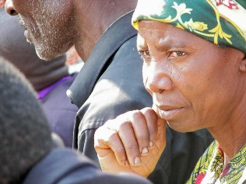
Gloire is a mother of five, and is happy her daughter-in-law is now pregnant with her first child. Gloire remembers her first pregnancy was difficult, and has learned the local health clinic is now encouraging pregnant women to go for ANC services. She is eager to ensure her daughter-in-law gets these services, and has talked to her daughter-in-law already about this, but knows her son will object. He is a strong believer that God gives and takes away life, and that intervening by going to the clinic shows a lack of faith. She is unsure how to talk to him about this, or what to say to convince him of the benefits of ANC.

PRIMARY AUDIENCE 2: FACILITY-BASED CLINICAL PROVIDERS
Dr. Yasamin, OB / GYN specialist in Meknès, Morocco
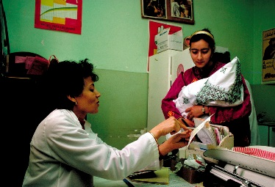
Dr. Yasamin works at a referral hospital in a district and supervises the various services related to maternity (ANC, delivery, post partum care) as well as other OB/GYN issues. She often works alone - when the hospital actually needs three or four OB/GYN specialists- and thus struggles with the workload. Her level of knowledge about PE/E is typically based on the country’s latest guidelines, which are outdated. Patients who are at risk of PE/E and who are coming to the hospital for regular ANC visits are usually identified during ANC and referred for treatment immediately. Other patients may show up at the hospital already convulsing. At this stage, the ability of Dr. Yasamin to save their lives is greatly reduced. Dr. Yasamin is dedicated to taking good care of all patients at her hospital, and he wishes that PE patients would be screened more systematically to ensure early detection and prevention of seizures.

Tilahun, 30, health officer working at a local health facility in Debre Berhan, Ethiopia
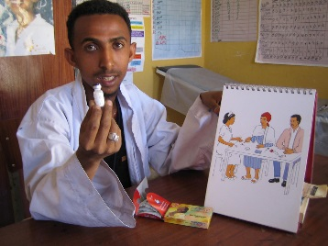
Tilahun works at a local health facility (not a referral hospital) and is usually supported by a few other staff. He is trying to do his best to ensure that all women who come to the facility are treated or referred as appropriate. Pregnant women come to his clinic for ANC and sometimes for delivery, sometimes due to complications. When a woman arrives at the clinic with signs of PE/E, Tilahun does not always feel comfortable treating it and at times chooses to refer the pregnant woman to the referral center. In some cases where the woman is already experiencing convulsions, he uses diazepam as treatment. He has heard about magnesium sulfate and knows that it can be used to treat PE/E, but he is not clear about the protocol, dosage and regimen, or how to handle possible side effects. He is also unclear about the possible effects of the drug on the mother and the fetus.

Anna, 53, trained birth attendant working at a health facility in Gulu, Uganda
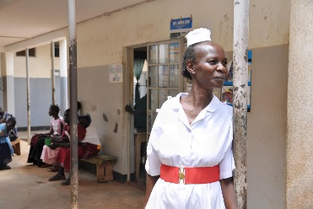
Anna likes her work and generally has good social status and recognition in her community. She has limited equipment and supplies to work with. Because of this, she is worried that she might not be able to properly treat all women under her care. She prefers to refer a woman rather than try to treat her if something happens. She is not very well informed on the signs of PE/E or the way to diagnose it (though she is very familiar with convulsions), and she would not know how to use magnesium sulfate even if it were available. She believes that magnesium sulfate should only be used at higher level hospitals and by a higher cadre of provider.

Sadia, 27, ANC nurse in Chittagong, Bangladesh
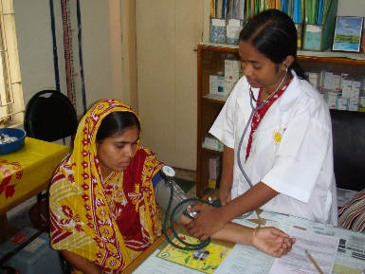
Sadia works at a local health center and provides screening to all pregnant women in the community. She is often overwhelmed by the number of women she has to see on a daily basis and she knows that people complain about long lines and waiting all day. As a result, she sometimes takes shortcuts to get her work done more quickly. In other cases, she sometimes records patient information rapidly without making the sufficient considerations in what the numbers may indicate and how referral and treatment should respond accordingly.
Typically, she recommends a urine test during the first ANC visit but does not offer it systematically for repeat visits. At her health facility, providers typically prescribe a urine test only if BP levels are elevated. However, the accuracy of BP machines is questionable, and sometimes she does not entirely trust the results. When a pregnant woman has signs of elevated BP, she recommends an antihypertensive drug but has no guarantee that the woman will come back for further monitoring and rarely has time to counsel clients on all the danger signs. She also knows that although she is meant to see mothers four times during their pregnancy, they may: 1) delay the first visit, 2) receive ANC care from multiple care settings, or 3) skip visits in between. As a result, she is unsure of the next time she will see a woman and it is unlikely that she will provide all ANC screening visits. Accordingly, this makes it difficult to consistently follow-up on issues identified during previous ANC visits or to ensure that the woman followed through on recommendations or referrals.

INFLUENCING AUDIENCE 1: DISTRICT AND LOCAL HEALTH OFFICIALS
Dr. Abena, District Level Health Official, near Accra, Ghana
Dr. Abena is the health officer in charge of one district. He is responsible for making sure that all the public and private sector facilities in his district follow government guidelines for all health protocols. He is also involved in budgeting health needs for the district, identifying sources of funds for commodities and equipment, organizing refresher training updates for the various government facilities and monitoring the quality of services in all centers of the district. He is ultimately responsible for his district’s health indicators. He often feels overwhelmed by the range of issues he has to address. He is also under-staffed and does not feel like he has enough time and resources to ensure the required quality of services and supply availability. He would like to be able to serve the needs of his local population better and he is motivated by the idea of being helpful and getting positive appraisals from his supervisors and local politicians.

Dr. Cume, district hospital manager, Nampula, Mozambique
Dr. Cume is the doctor in charge of a district hospital. He is a public sector appointee and provides human, financial and operational management for the hospital. He works with both a limited budget and a limited number of staff. He knows that maternal deaths during delivery are a major problem and an area of increased attention for his supervisors and national level officials. However, he does not feel like he has enough time and resources to ensure the required quality of services and supply availability in the hospital. He would like to be able to serve the needs of his patients better and he is motivated by the idea of being helpful, getting positive appraisals from his supervisors and the local politicians.
INFLUENCING AUDIENCE 2: COMMUNITY HEALTH WORKERS (CHWs)
Kanta, 43, CHW in Bangladesh
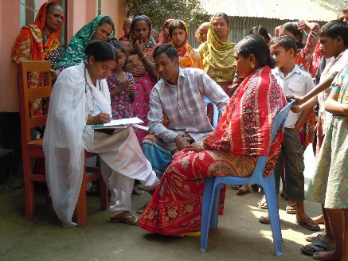
Kanta is a middle-aged woman with three children. She has been trained to become a CHW by the government. Her training focused on identifying key diseases and health concerns for various age groups. She has been trained to identify pregnant women in her community and to encourage them to attend ANC regularly. She is also trained to identify danger signs associated with pregnancy. She is not completely clear about all the danger signs associated with pregnancy but she knows about medical issues like heavy bleeding and convulsions during pregnancy. Through her CHW role, she has gained status and prestige within the community (they call her “doctor”) and she gets a stipend that allows her to improve her financial situation. She would like to know more about the various problems that can arise during pregnancy and childhood. In addition, she would like to have more job aides on PE/E so that she can better explain the importance of seeking treatment for PE/E to her community.

