Step 3: Choose the Intended Audiences

Primary and Influencing Audience Segments (with rationale for segment selection)
PRIMARY AUDIENCES
Primary audience 1: Pregnant women planning to deliver at home - Pregnant women are directly affected by PPH and in general prepare for birth by gathering items they will need, whether giving birth at home or in a facility. Although misoprostol can be used in facility or home-based settings, given that oxytocin is the first line drug for PPH prevention and treatment, primary audience 1 will focus specifically on misoprostol for home births, where oxytocin is less likely to be available and women could potentially request and use misoprostol. It might be useful to further segment this audience according to differences in their health seeking behavior in a specific area or country. In some settings, for example, women who have more living children might be more likely to deliver at home than at a health facility. Consider segments like rural versus urban women, and multiparous versus nulliparous women. This strategy provides examples for a young mother-to-be and an experienced mother.

Primary audience 2: Community-level providers - Community-level providers can play a direct role in preparing for and assisting birth, as well as educating women and communities about the benefits of misoprostol for PPH prevention and treatment. Community-level providers are frontline workers, often working in the same community in which they live. They can include CHWs, TBAs, social workers, and pharmacists, and often have a deep understanding of the customs in their community. This strategy provides examples for working with CHWs and TBAs. It is important to note that any intervention targeted at reaching CHWs with the goal of improving maternal health would need to cover more than PPH and address other aspects of maternal health and pregnancy related risks for better impact (e.g., nutrition, pre-eclampsia/eclampsia, sepsis, ANC visits, recognition of danger signs, facility based deliveries, etc.). Also, supervisors need to have a clear understanding of any new roles or information these workers are being asked to provide to their communities.

Note also that it may be necessary to conduct additional research around local population health seeking behaviors and providers of health information and use these to inform the audience profile and strategic design.
INFLUENCING AUDIENCES
Influencing audience 1: Male partners, mothers, and mothers-in-law - Male partners, mothers, and mothers-in-law often have great influence on how women prepare for and experience birth. They might decide where and with what assistance the birth will take place, what drugs or herbs may be used, and how money will be spent.
Influencing audience 2: Facility-based providers - Facility-based providers advise pregnant women, teach by example, are gatekeepers and implementers of community-based distribution programs, and should use misoprostol when oxytocin is not available. They have oversight of others, including community workers, who administer or promote the use of misoprostol. Some might educate about misoprostol or distribute but not administer it. Pharmacists may stock and dispense the drug.
Influencing audience 3: Community leaders – Particularly active community members and leaders, including religious leaders, play a key role in maintaining or changing community norms, including those related to health-seeking behavior and childbirth.

Audience Profiles
PRIMARY AUDIENCE 1: PREGNANT WOMEN
Aminata, 20, young mother-to-be living in Zinvié, Benin.
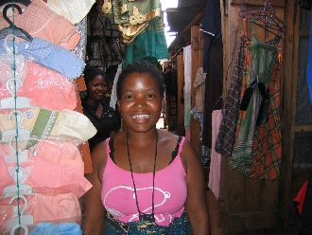
Aminata is 20 years old, married, and pregnant with her first child. She completed primary school and then worked on her family’s farm until she married. Now she sells clothes in the market. Her nearest health center is 20 kilometers from where she lives. She has made two ANC visits so far and expects her baby to be born in four months. She plans to give birth at home as that is what most women in her community do and the facility is too far. She is a little bit afraid because she has known or heard of several women who died in childbirth, but she is looking forward to being a mother.

Theresa, 34, experienced mother in Napula Province, Mozambique.
Theresa is 34 years old, married, and pregnant with her 5th child. Her first child died soon after birth, at home. She had her next child at the district hospital and the next two at home with a TBA, which she plans to do for this birth. In addition to managing her household she sells vegetables in the local market. Even though she is six months pregnant, she has not yet had time to go and wait at the ANC clinic. She plans to do so this month. The nearest health center is 10 kilometers away.

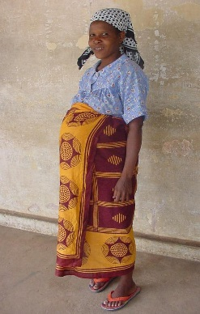
PRIMARY AUDIENCE 2: COMMUNITY-LEVEL PROVIDERS
Kanta, 43, community health worker in Kaduna, Nigeria.
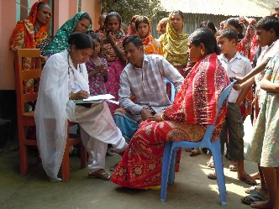
Kanta is a middle-aged woman, she has three children and has been trained to become a CHW (by the government or an NGO) and help her community improve health-seeking behaviors. Her training focused on identifying key diseases and health concerns for various age groups. For pregnant women, she has been trained to identify them, encourage them to go for ANC regularly, and watch for danger signs. She is not completely clear about all the danger signs but she knows of heavy bleeding and convulsions during pregnancy. Through her CHW role, she gains status and prestige within the community (they call her “doctor”) and she gets a stipend that allows her to improve her financial situation. She would like to know more about the various problems that can arise during pregnancy and childhood and she would like to have more tools so that she can better explain the importance of seeking treatment to her community. She would also like to be able to provide treatments appropriate for her skill level.

Nora, 32, traditional birth attendant in Copán Ruinas, Honduras.
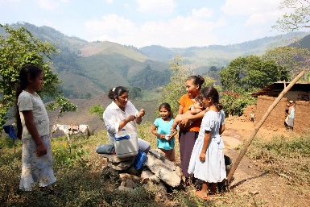
Nora has been delivering babies in her town for 10 years, following in the footsteps of her mother and grandmother and their mothers and grandmothers before them. She has received limited training from a local NGO, focusing on use of a safe birth kit for clean deliveries and referring women with danger signs. Delivering babies provides income and prestige for her, and she is very concerned about the welfare of women in her village. She is happy to refer her women in the case of likely or actual emergencies, but she does not feel that the health center staff value what she does. She has seen many cases of PPH and its consequences and wants to be able to prevent or treat PPH during home deliveries.
INFLUENCING AUDIENCE 1: MALE PARTNERS, MOTHERS, MOTHERS-IN-LAW
Thomas, 35, married father of one living in Kadoma, Zimbabwe.
Thomas is 35 years old with one wife and one child. He is responsible for making decisions for and about his family on everything from health care to education to regular purchases. He has never accompanied his wife to the health center and rarely goes there for himself. He is happy and proud that his wife is expecting their second child, but they do not normally discuss the pregnancy or what happens at her ANC visits – that is the women’s domain. Still, he loves his wife and wants her and their children to be healthy.

Elira, 52, expectant grandmother advising on her daughter-in-law’s pregnancy in Elbasan, Albania
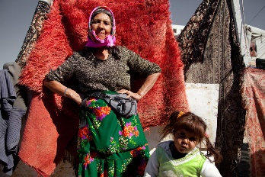
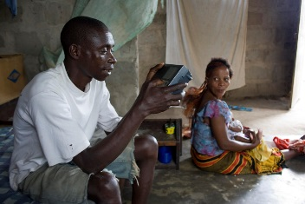
Elira is 52 years old and has given birth to 8 children with the help of a TBA. One of her children died within weeks of his birth. Another died before age 3. Some of her deliveries were difficult, but she survived and believes the old ways are good ways since they have worked for generations. When the government opened a health center in her village, she began taking her children for immunization and other types of care. She rarely seeks health care at the government facility, preferring to seek assistance from her long-trusted traditional healer. She is anxious to have grandchildren and oversees her daughter-in-law’s pregnancy and delivery.
INFLUENCING AUDIENCE 2: FACILITY-BASED HEALTH PROVIDERS
Sadia, 27, ANC nurse in Chittagong, Bangladesh
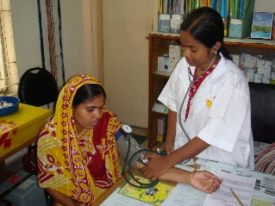
Sadia works at a local health center and provides screening to pregnant women in the community. She is often overwhelmed by the number of women to see in a day, and she knows that people complain about long lines and waiting. As a result she may take shortcuts in her work or give patients limited information about what to do or expect during pregnancy and childbirth. She is unsure how often PPH occurs in her area and unaware of misoprostol as a simple, cost-effective way to prevent it. She knows that although she is meant to see mothers four times during their pregnancy, they may: 1) delay the first visit, 2) receive ANC care from multiple care settings, and/or 3) skip visits in between. As a result, she is unsure of the next time she will see her clients and it is unlikely that she provides all four ANC screening visits to the same woman. Typically, she does not mention PPH during the first ANC visit because she does not want to frighten the mother-to-be and thinks it is too soon for her to remember anyway. In addition, she does not typically discuss danger signs, ask women where they intend to deliver, or advise them to deliver with a skilled attendant at that first visit. She is unaware of the option of providing patients with misoprostol to take home so they have it wherever they deliver.
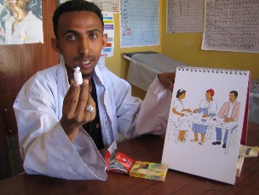
Dr. Tilahun, 31, health officer and doctor working at a local facility in Debre Berhan, Ethiopia
Dr. Tilahun works at a local health facility and is usually seconded by a few staff. He is trying to do his best to ensure that all women showing up to the facility are treated or referred as appropriate. He has heard about misoprostol and knows that it can be used to prevent and treat PPH, but he is not clear about the protocol, dosage and regimen, or about handling possible side effects. He is also concerned about fears that misoprostol might be given prematurely or used to abort. Women come to his clinic for ANC and sometimes for delivery; they also show up in case of complications, unless they head directly to the referral hospital. When a woman shows up with PPH, Dr. Tilahun may not have oxytocin and may decide to send her to the referral center.

Anna, 53, trained birth attendant working at a local health facility in Gulu, Uganda
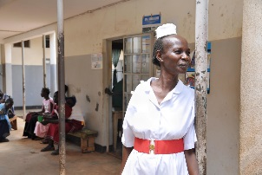
Anna likes her work at the health center and tends to have a good social status and recognition in her community. She has limited equipment and supplies to work with, and she is worried that something could happen to the women under her care. She prefers to refer a woman rather than try to treat her if something happens. She is not very well informed on the active management of the third stage of labor (AMTSL), and she would not know how to use misoprostol even if it were available. However, she has heard about misoprostol and feels that it could be a reliable solution for PPH at the primary health care level when oxytocin is not available.

INFLUENCING AUDIENCE 3: COMMUNITY LEADERS
Martha, 40, community leader in Garissa, Kenya.
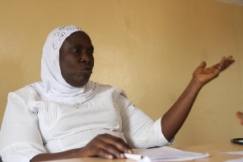
Martha leads a local women’s group. She is 40 years old and has five children. She wants to see the condition and position of women in her community improve. Her group holds monthly meetings where they discuss problems and what is going well. They also share solutions and things they have learned. Each month they focus on a specific topic in addition to open discussion on whatever attendees are concerned about at that time. Group members also contribute a small sum of money each month to give to the member whose turn it is to receive. The women use this money for special purchases – seeds, equipment, health care, large household items, etc. Martha knows the life history of everyone in the group and regularly pays them visits, listens, and gives advice. She has seen too many women in her village die after giving birth. She believes in some traditional ways, but she also sees the value in modern ways, including modern health care.
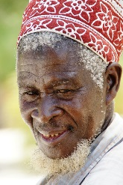
Moussa, 57, community religious leader in Niamey, Niger.
Moussa is 57 years old and has four children. He serves as a religious leader in his village. The men and women in his community look to him for his knowledge and wisdom on life matters as well as religious matters. He welcomes opportunities to improve health in his area, and new health programs often consult him before launching. He has a healthy, hard-working family with a very productive farm. His first wife died in childbirth. He knows first-hand how hard this was for him and his other children.

