Step 3: Choose the Intended Audiences
Primary and Secondary Audience Segments
Primary audiences

Primary audience 1: Caregivers of children under five

Primary audience 2: Community Health Workers

Primary audience 3: Non-clinical providers such as owners and employees in pharmacies and local shops (public and private) – Depending on the country, non-clinical providers may be an secondary audience

Primary audience 4: Clinical providers (public and private) – Depending on the country, clinical providers may be an secondary audience

Influencing audiences

Influencing audience 1: Extended family / Mothers-in-law/ Community Members

Although health system officials and decision-makers are a potentially important influencing audience, they are not included in this communication strategy as key messages for advocacy on amoxicillin are found in Scaling Up Lifesaving Commodities for Women, Children, and Newborns: An Advocacy Toolkit, which provides advocacy resources for utilizing the Commission platform to raise awareness and engage stakeholders in addressing commodity-related gaps in policy. See: http://www.path.org/publications/detail.php?i=2381

Audience Profiles
PRIMARY AUDIENCE 1: Caregivers of Children under Five
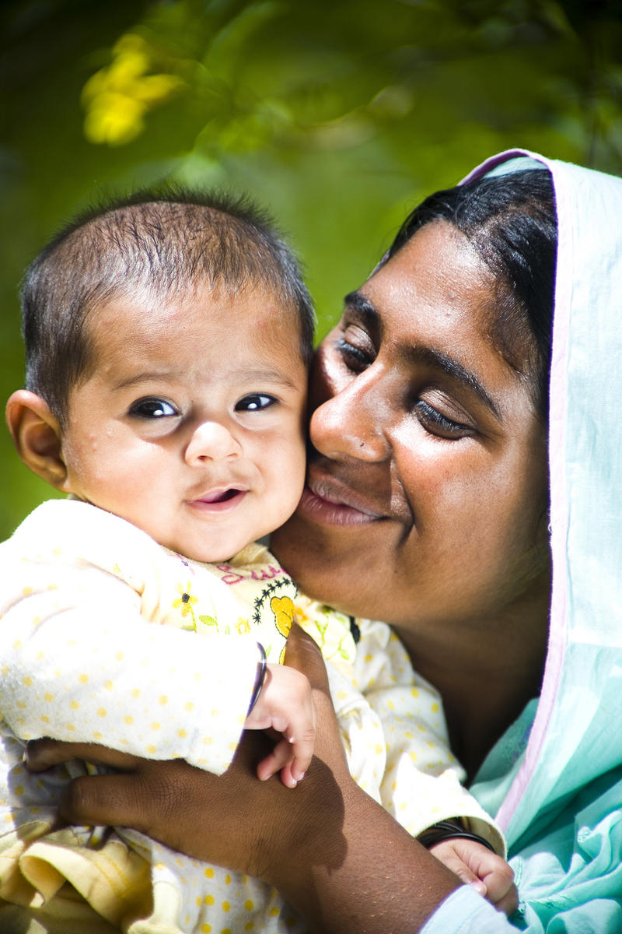
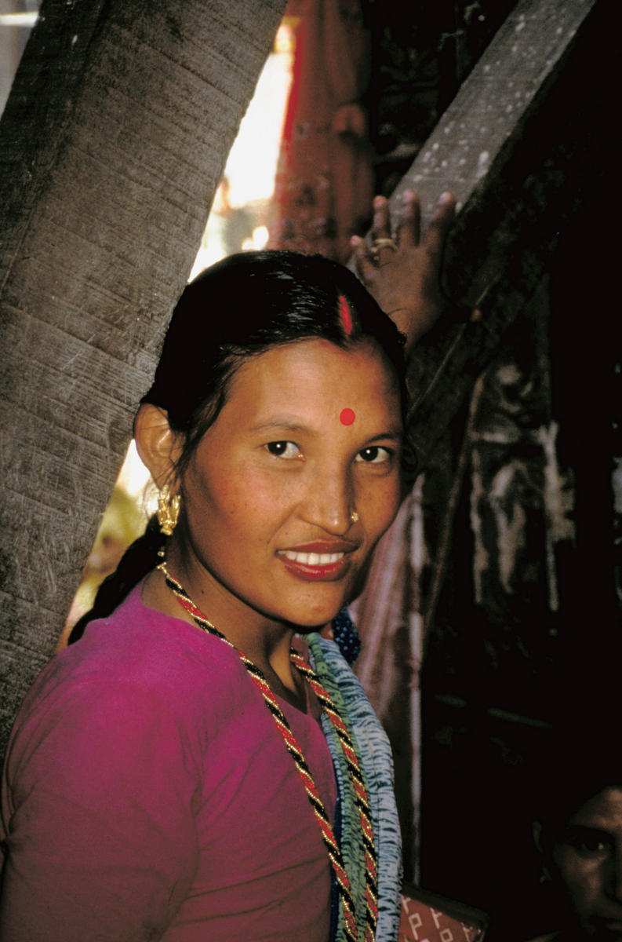
Bina, 21, a young mother in the outskirts of Kathmandu, Nepal
Bina has two children, ages 4 months and 3 years. She and her family live in a neighborhood near many relatives whose opinions are highly influential on how she cares for her children’s health. Bina cares for her children and tends a small garden. Her husband is a laborer, and they depend on his work for their income. There is a CHW who visits their neighborhood every few months, a woman Bina admires because she is educated and she travels. The CHW recently spoke about taking children with fast breathing to the health center for treatment. Bina’s older daughter was sick with fast breathing before, and Bina wanted to take her to the doctor. Friends and neighbors told her that fast breathing could not be cured with western medicine, so she used traditional medicine and her daughter recovered slowly. Even though Bina admires the CHW, she is not sure what do if her children are sick again.

Neha, 29, a mother of three in rural Haripur, Pakistan
Neha lives with her husband, her three children, ages 5, 3 and 2 months, her mother-in-law and her brother-in-law. Neha is responsible for cooking for the family, cleaning the house and yard, raising her children and helping her mother-in-law. Her husband is a farmer, and whenever possible, he finds construction jobs to supplement their income. Neha cooks over wood and dung fires, and if it is cold, she cooks inside. She thinks the smoke from cooking sometimes causes her children’s coughs and respiratory problems. Recently, her 3-year-old daughter suffered from a fever and fast breathing, but Neha and her husband thought it was not serious and did not seek care immediately. After a day or two she sought advice from the CHW, who was not able to diagnose anything, but did refer her to the clinic. Neha was hesitant to go to the clinic because of the distance and long wait for care. However, when her daughter was really struggling to breath she asked her husband if they could go. He was reluctant to do so but agreed. When they saw the doctor, he diagnosed malaria and provided treatment. However, her daughter seemed to get worse. They returned to the clinic and a different doctor diagnosed pneumonia and gave Neha a prescription for amoxicillin. Neha was afraid to ask too many questions and isn’t sure how she should give the treatment to her daughter.

PRIMARY AUDIENCE 2: Community Health Workers
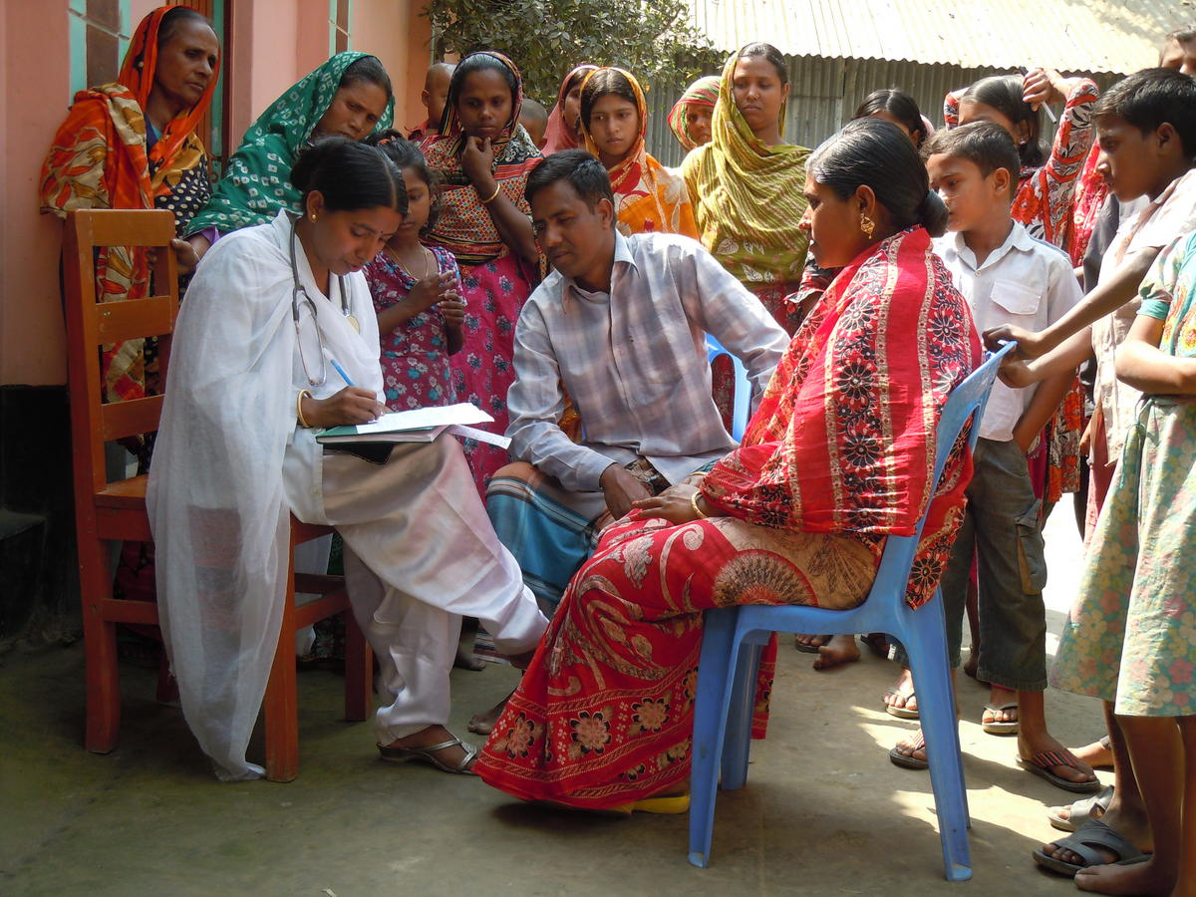
Kanta, 43, Community Health Worker in Bangladesh
Kanta is a community health worker in the rural communities to the north of Bangladesh. She is a mother with three children, ages 5, 8 and 10. She was selected by community leaders to be trained as a health educator. She is given a small stipend by an NGO and receives supervision visits once per quarter. She visits households and gives group talks, primarily focused on child health, including malaria, diarrhea and pneumonia. The women trust Kanta, and she is now recognized and welcomed in all the villages. However, mothers are often reluctant to buy antibiotics for pneumonia, saying that pneumonia is caused by supernatural forces and cannot be cured. She likes the pre-packaged treatment because it is easy to explain the doses and helps her remember the dosages.

PRIMARY AUDIENCE 3: NON-CLINICAL PROVIDERS
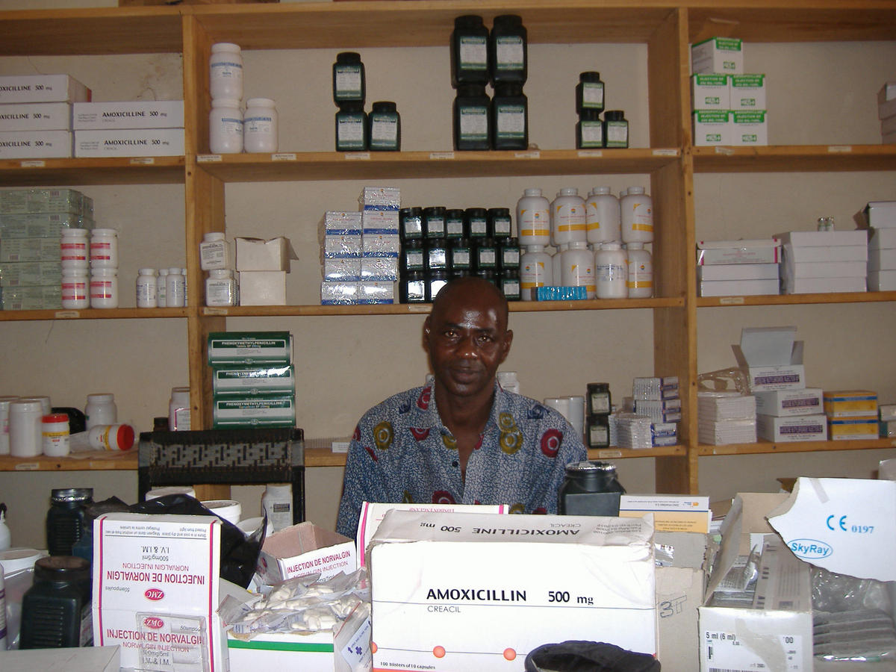
Issa, 29, pharmacy worker in Bamako, Mali.
Issa manages a small pharmacy outside Bamako, Mali. His father is a trained pharmacist and owns several pharmacies in the region. Issa prides himself on having learned about medicine and treatment of common illnesses working with his father. He knows that the community respects his knowledge and that he is often the first place families come for medical advice. He was trained on treatment of childhood illnesses by several NGO programs, including prescribing ACT for malaria and amoxicillin for pneumonia, and he appreciates the job aids that the NGOs give him to help explain dosages to parents. Although Issa knows that amoxicillin is the correct treatment for pneumonia, many customers ask him for malaria treatment whenever their child has a fever, even if the child is coughing and breathing quickly, as they trust malaria treatment. As he makes more money selling ACT, and he does not want to be wrong about his diagnosis, he sells customers what they ask for. Representatives from pharmacy companies also provide training, including gifts such as promotional materials to decorate his shop, pens and notepads. These representatives are knowledgeable, friendly and they offer him incentives to prescribe the medicines they promote, so he regularly follows their advice.

PRIMARY AUDIENCE 4: CLINICAL PROVIDERS
Dr. Simaret, MBBS, 38, just outside Addis Ababa, Ethiopia
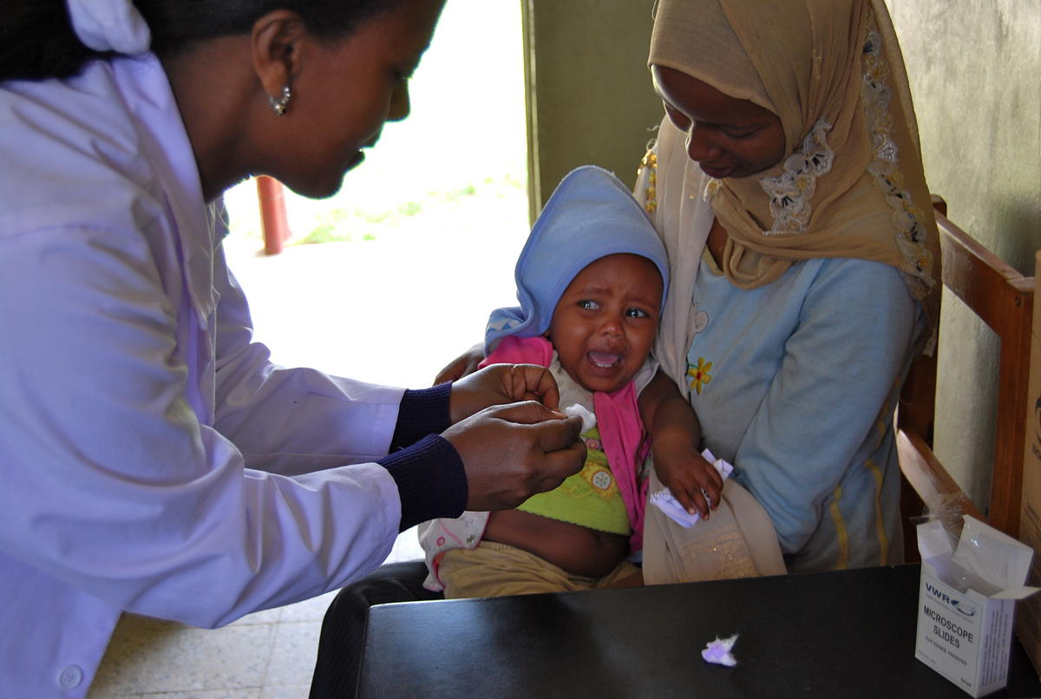
Dr. Simaret is a doctor in one of the busiest health facilities near Addis Ababa, Ethiopia, and she operates a small private clinic on evenings and weekends. She stays updated in medical education by attending conferences and government trainings, and she is a member of the local medical doctors association. She cares about her patients, especially the young mothers, and she wants to give them the best possible care. However, Dr. Simaret sees more than 50 patients a day, and she may not spend as much time as she would like educating her patients. Pneumonia is one of the most common illnesses she treats, and even though the Health Extension Workers have been counseling mothers to seek treatment immediately, many children arrive having been ill for several days. She recently learned that the new guidelines call for amoxicillin, but she is skeptical it is the best treatment, since she has been working for a long time prescribing other antibiotics and cough syrups for pneumonia. She worries that if she follows the new guidelines, and then does not fully heal the children, her reputation will suffer and she may lose patients who come to her private clinic.
INFLUENCING AUDIENCE 1: EXTENDED FAMILY MEMBERS & COMMUNITY MEMBERS
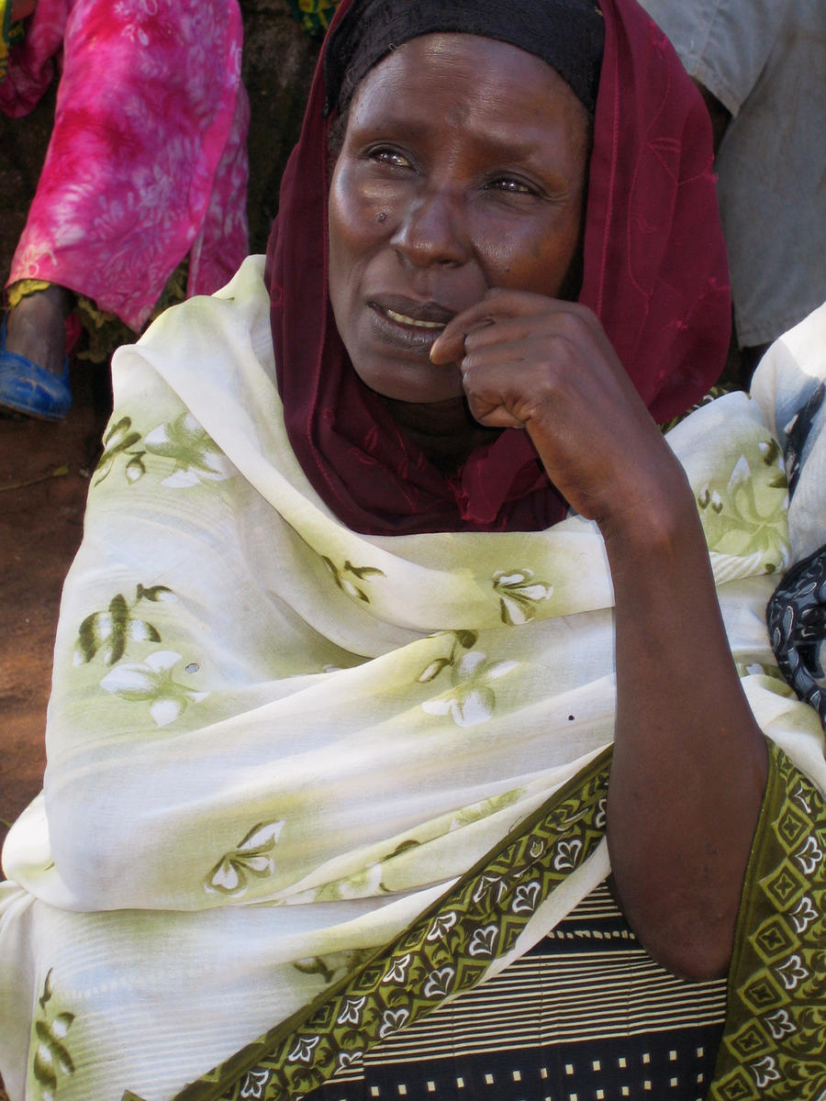
Mrs. Bekele, Asella, Ethiopia
Mrs. Bekele is very proud that her son is married and has two children and has a job to provide for his family. Her daughter-in-law is respectful and is good at keeping the home, and they get along well. Mrs. Bekele raised four healthy children by asking her own mother-in-law for advice and remedies, and she expects her daughter-in-law to now consult with her instead of spending money going to a doctor. She believes that coughing and respiratory problems are caused by the evil eye and that her daughter-in-law must take care so that her children are not affected. Mrs. Bekele cares about her family’s reputation and does not want her daughter-in-law to go out of the house more than necessary in case the neighbors begin to comment. Mrs. Bekele watches TV and speaks to her friends at the church each morning, and they share stories about their families.

