Executive Summary

Communication Materials from the Western Highlands Integrated Program Region of Guatemala: A Consistency Analysis of Key Messages

Background
The USAID Mission in Guatemala requested that HC3 examine the consistency of messages disseminated in the Western Highlands Integrated Program (WHIP) region. Although there are multiple development portfolios in play in the WHIP region, most (if not all) WHIP projects are mandated to promote nutrition and health behaviors that fall within the window of the First 1,000 Days. Therefore, concern arose that these behaviors may be promoted inconsistently or with conflicting messages. Any inconsistency could cause confusion among the population of the WHIP region, considering that multiple projects are present in many of the same departments within the WHIP, and that it is not uncommon for individuals to migrate between departments.

HC3 collected and analyzed a total of 131 communication materials with the end goal of characterizing the consistency and agreement of messages being disseminated in the WHIP region of Guatemala regarding key health and nutrition behaviors recommended during the first 1,000 days of life. These materials deal with topics of nutrition, health, agriculture, family planning, and others related to the mandates of several WHIP projects. Projects whose materials are included in this analysis are: Anacafé Rural Value Chains (RVC), Alianza para la Nutrición, Nutri-Salud, PAISANO, PLANFAM, SEGAMIL, and UNICEF.

Methods
With the aim of identifying areas of consistency and inconsistency within each topic and across the materials and projects, key messages from these 131 materials were analyzed. To accomplish this, the 131 materials were logged into a digital inventory and their messages transcribed verbatim into this inventory. The key messages and recommended behaviors were extracted from the materials. A database was subsequently created and organized the key messages by 31 main themes. Consistency was then evaluated across each of the 31 main themes.

The methodology of the consistency analysis was both qualitative and quantitative. Key messages for each main theme were compared side-by-side, across all projects that included messages on that theme in their materials. This comparison produced a qualitative assessment that is included in the full report, accompanying the key message comparison. An example of one of these comparisons and assessments can be found in Table 1.
Table 1: An example of a comparison of key messages for the theme of danger signs in newborns, including both qualitative and quantitative results.
Nutri-Salud | PAISANO | SEGAMIL
Doesn’t want to breastfeed | Can’t breastfeed | Can’t breastfeed
Is very hot | Is very hot or has a fever | Has a fever
Is very cold | Is very cold | Is very cold
Difficulty breathing | Difficulty breathing | Difficulty breathing
Is very small | Is very small or has low weight | Is very small
Is purple | Is purple | Is pale, purple, or yellow
Is faint | Is faint | Is faint or has trouble waking
 | Red belly button, with bad odor or pus | Has a red belly button
 | Has attacks or convulsions | Barely moves or has convulsions
 | Doesn’t cry, or cries a lot | - Vomits everything eaten  - Has hives, bruising or bleeding
Results:
- 7 similar messages in 3 projects
- 2 similar messages in 2 projects
- 3 similar messages in 2 projects

There is a high level of consistency across projects and materials regarding what to do if a danger sign is noted in a newborn: go immediately and quickly to the nearest health clinic. The three projects’ materials have seven newborn danger signs in common. PAISANO and SEGAMIL’s materials mention 5 additional danger signs in their materials, of which two are in common and three are not.

In the materials of the three projects, the age at which a baby transitions from a newborn to a young child is not defined.

The topic of danger signs in newborns achieved a ranking of medium-high consistency through the quantitative calculation of consistency.

Through a quantitative analysis, the level of consistency or inconsistency of each of the 31 topics was calculated using a scoring methodology to rank themes on a scale of high to low consistency. The quantitative ranking was calculated by scoring each message based on whether it appeared consistently across all projects that included messaging on that topic. These scores were then added and averaged using the total number of key messages found on that theme within the materials. Although not a definitive measurement of consistency, this ranking represents an approximation of consistency that, while it does not reflect the complexity of the messages within each topic, is nevertheless a useful method for observing patterns of consistency across themes.

Results
The analysis revealed general agreement across the reviewed SBCC materials on the themes related to health and nutrition behaviors recommended during the First 1,000 Days of life. Few cases of outright disagreement and no cases of blatantly incorrect information were found. However, many cases were found in which although the behavior and key messages are generally promoted consistently across the materials of the various projects, the supporting messages may not be agreement, or they reflect differing priorities or points of view. It was seen in some cases that recommended behaviors were ambiguous or messages lacked the necessary supporting information to carry out the behavior. In other cases, supporting information varied across materials, with some projects placing greater emphasis on certain messages over others. It is important to note that in many cases it is more correct to say that there are differences between the set messages used in the different projects, rather than outright inconsistencies; however, in this report all types of are labeled “inconsistency.”

Table 2: A summary of the consistency of the 31 analyzed topics.
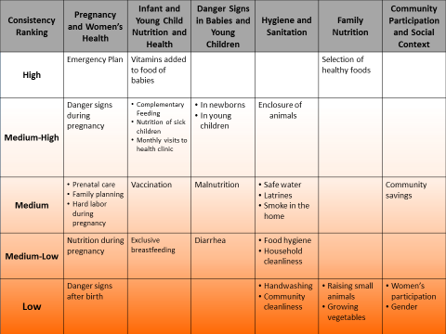

A summary of the findings of the consistency analysis appear in Table 2. Approximately 60 percent of the 31 themes in Table 2 have medium, medium-high, or high consistency, with the remaining 40 percent ranking medium-low or low. Higher consistency was found among themes that overlap with behaviors important to the First 1,000 Days, such as the categories of Pregnancy and Women’s Health, Infant and Young Child Nutrition and Health, Danger Signs in Babies and Young Children, and Hygiene and Sanitation. Behaviors that fall outside the priority behaviors for the First 1,000 Days, such as the themes of Family Nutrition and Community Participation and Social Context, had lower consistency overall. The topics with the lowest level of consistency and agreement were: danger signs in the mother after giving birth, hand washing, community cleanliness, raising small animals, growing vegetables, women’s participation, and gender.

Given that the projects whose materials were included in this analysis have different but overlapping mandates, objectives, and goals, it’s expected that an analysis such as this would find differences in the priorities or emphasis of the messages and materials of the projects. Omissions of unessential messages or topics could be expected and necessary. However, where projects have overlapping goals, using the same basic recommendations and similar language in communication materials would be beneficial to all.

Analysis of the “Ruedas”
An additional comparison was done of the three “ruedas” in use by the three main nutrition and health projects implemented in the WHIP region: Nutri-Salud, PAISANO, and SEGAMIL (Figure 1). These “ruedas” are the main communication tools used during home visits, and contain the core nutrition and health messages of these programs. The language used and behaviors promoted by the “ruedas” represent the key, topline messages promoted by each of these three projects. As such, it was seen as essential to perform an additional and more detailed assessment of their consistency.

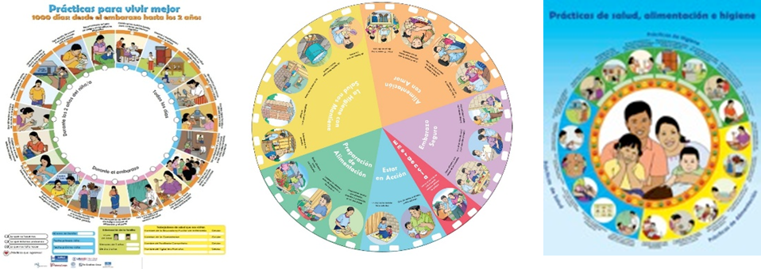
This analysis revealed that the three ruedas included different topics that reflect differences in the mandates of their respective projects. There were 25 topics found across the three ruedas. 11 topics appeared in all three ruedas, while six others appears in only two of the ruedas, and eight were included in only one of the ruedas. Of the topics that appear in all three ruedas, consistent language was used to promote a similar or identical behavior for four of the topics. Of topics that appear in two ruedas, such consistency was found in three topics. Overall, 10 topics appear in more than one rueda and do not use consistent language to promote similar or identical behaviors. Of the 25 topics, 14 do not appear in all three ruedas. The analysis revealed that topics that fall within the categories of health and nutrition of pregnant women, babies, and children had more consistency.
Figure 1: The "ruedas" of Nutri-Salud, PAISANO, and SEGAMIL, respectively.

Best Practices for Strategic and Effective Communication
In addition to the consistency analysis, approximately 20% of the materials were analyzed against best practices for strategic and effective communication. Some examples of these best practices include the benefits promoted in the materials, if the materials take into account the barriers to perform the recommended behaviors, if the materials aim to impact the audience’s emotions, among others.

The analysis of best practices for strategic and effective communication revealed that the majority of materials were designed to transmit information to women (mothers, pregnant women, and women in general) and fathers, using clear colloquial language, with a directive and instructive tone. The materials were designed for individual use (in printed format) or interpersonal use (during home visits or group sessions). The materials appear to be designed to mainly transmit information and to promote knowledge within target audience members, in addition to promoting a positive attitude toward the recommended behavior, and to a lesser extent, an intention to perform them. They are culturally sensitive, but do not incorporate elements of the Mayan worldview. They include many messages; the typical material included more than 10 messages that would be seen or heard by the audience each time they are exposed to the material. A good proportion of materials incorporated some type of emotional appeal, and about half addressed barriers to performing the behavior.

Conclusions and Recommendations
The consistency analysis revealed varying levels of consistency across 31 topics related to health and nutrition. The majority of topics analyzed have medium or high consistency. Additionally, differences or inconsistency in messaging may be due to variations in project mandate, or strategic decision-making on the part of each project. Based on these facts, HC3 Guatemala recommends:
- That WHIP implementing partners collectively assess each topic to determine which cases of inconsistency are strategic and which are not, and decide which cases of inconsistency need to be addressed through the alteration, addition, or subtraction of key messages.
- That WHIP implementing partners consult with technical experts to determine the appropriate way to resolve instances of inconsistency that are the result of conflicting recommendations from health and nutrition experts.
- Taking into account the results of the analysis of best practices for strategic and effective communication: That WHIP implementing partners review the available evidence regarding the needs of the population of the WHIP in relation to key behaviors recommended during the First 1,000 Days. This includes knowledge, attitudes, current behaviors, use of media, trusted sources of information, barriers to performing these key behaviors, and any other relevant ideational factors. With this information, WHIP implementing partners and technical experts can identify which communication strategies will be most effective for each behavior, and ensure that communication materials most appropriate to meet the needs of the target population are used, or that current materials be modified to achieve higher levels of effectiveness.

