  - <Logo>
  - <Organisation Name>

  - <Project title>

Monitoring & Evaluation Plan

Date

Contents
Acronyms ii
1 Introduction 1
1.1 Purpose of this plan 1
1.2 Project summary 1
2 Logical Framework 2
3 Indicators 3
4 Roles & Responsibilities 5
5 Data Flow 6
6 Data Management 7
6.1 Storage 7
6.2 Analysis 7
6.3 Privacy 7
Appendices 8
<Tool Title> 8
<Tool Title> 8
<Tool Title> 8

Acronyms

Introduction

Purpose of this plan
<Describe what the purpose of the monitoring and evaluation plan is, such as who prepared it, for which audience and why>

Project summary
<Provide basic information on the project that this monitoring and evaluation plan is for>
Title | <Insert>
Starting Date | <Insert>
Duration | <Insert>
Partners | <Insert>
Target Area | <Insert>
Beneficiaries | <Insert>
Cost | <Insert>
Funding Source | <Insert>
Goal | <Insert>

M&E Framework

 | INDICATOR | DEFINITION  How is it calculated? | BASELINE  What is the current value? | TARGET  What is the target value? | DATA SOURCE  How will it be measured? | FREQUENCY  How often will it be measured? | RESPONSIBLE  Who will measure it? | REPORTING  Where will it be reported?
Goal
Behavior Outcomes | Service Provider  Caregivers
Communication Outcomes | Service Provider  Caregivers
Outputs

Indicators

Indicator | <Insert>
Definition | <Insert>
Purpose | <Insert>
Baseline | <Insert>
Target | <Insert>
Data Collection | <Insert>
Tool | <Insert>
Frequency | <Insert>
Responsible | <Insert>
Reporting | <Insert>
Quality Control | <Insert>

Indicator | <Insert>
Definition | <Insert>
Purpose | <Insert>
Baseline | <Insert>
Target | <Insert>
Data Collection | <Insert>
Tool | <Insert>
Frequency | <Insert>
Responsible | <Insert>
Reporting | <Insert>
Quality Control | <Insert>

Indicator | <Insert>
Definition | <Insert>
Purpose | <Insert>
Baseline | <Insert>
Target | <Insert>
Data Collection | <Insert>
Tool | <Insert>
Frequency | <Insert>
Responsible | <Insert>
Reporting | <Insert>
Quality Control | <Insert>

Roles & Responsibilities

Role | Responsibilities
<Insert> | <Insert>
<Insert> | <Insert>
<Insert> | <Insert>
<Insert> | <Insert>
<Insert> | <Insert>
<Insert> | <Insert>
<Insert> | <Insert>
<Insert> | <Insert>

Data Flow

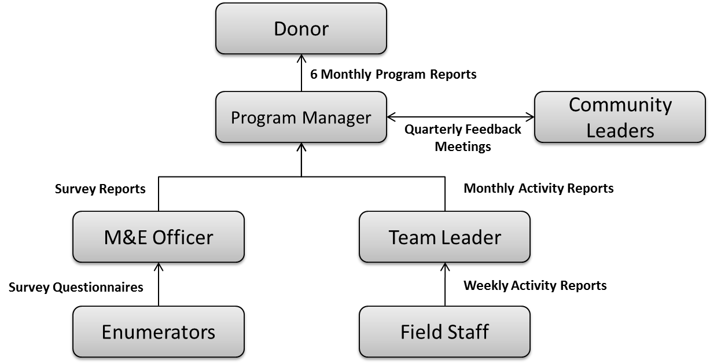
<Insert description of the data flow process>

Data Management

Storage
<Describe how the data collected will be stored. For example, will it be stored in a spread sheet, database, hard copies, etc. How will it be backed up? How long will it be stored for? Data for different indicators may be stored in different ways>

Analysis
<Describe which software / tools will be used to analyse the data, such as SPSS, Stata, Excel, Tableau Public, etc>

Privacy
<Discuss any privacy issues with the data and how they will be addressed. For example, if you are collecting personal medical records how will they be kept confidential, who will have access to them, when will they be destroyed, etc>

Appendices

<Tool Title>
<Insert tool>

<Tool Title>
<Insert tool>

<Tool Title>
<Insert tool>

